**Practical No. 07**

**TITLE:** GRAPHICAL PRIMITIVES USING ANDROID STUDIO

**AIM:** IMPLEMENT GRAPHICAL PRIMITIVES USING ANDROID STUDIO

**APPARATUS:** ANDROID STUDIO

**THEORY:**

* **activity_main.xml**

<?xml version="1.0" encoding="utf-8"?>

<RelativeLayout xmlns:android="http://schemas.android.com/apk/res/android"

xmlns:app="http://schemas.android.com/apk/res-auto"

xmlns:tools="http://schemas.android.com/tools"

android:layout_width="match_parent"

android:layout_height="match_parent"

android:background="@drawable/bg22"

tools:context=".MainActivity">

<androidx.appcompat.widget.Toolbar

android:layout_width="match_parent"

android:layout_height="wrap_content"

android:background="#000133"

android:elevation="4dp">

<TextView

android:layout_width="wrap_content"

android:layout_height="wrap_content"

android:textSize="27dp"

android:gravity="center"

android:layout_marginStart="4dp"

android:padding="2dp"

android:textStyle="bold"

android:text="@string/app_name"

android:textColor="#f1e1cc">

</TextView>

<ImageView

android:layout_width="57dp"

android:layout_height="55dp"

android:layout_gravity="center"

android:layout_marginStart="57dp"

android:layout_marginEnd="20dp"

android:src="@drawable/bg12221"

android:padding="10dp">

</ImageView>

android:textStyle="bold"

android:text="@string/app_name"

android:textColor="#f1e1cc">

</TextView>

<ImageView

android:layout_width="57dp"

android:layout_height="55dp"

android:layout_gravity="center"

android:layout_marginStart="57dp"

android:layout_marginEnd="20dp"

android:src="@drawable/bg12221"

android:padding="10dp">

</ImageView>

</androidx.appcompat.widget.Toolbar>

<ImageView

android:layout_width="match_parent"

android:layout_height="match_parent"

android:layout_marginTop="55dp"

android:id="@+id/image">

</ImageView>

</RelativeLayout>

**Conclusion:** Thus we implemented the installation o

* **MainActivity.java**

package com.example.graphicalprimitives;

import androidx.appcompat.app.AppCompatActivity;

import android.graphics.Bitmap;

import android.graphics.Canvas;

import android.graphics.Color;

import android.graphics.Paint;

import android.graphics.Path;

import android.graphics.drawable.BitmapDrawable;

import android.os.Bundle;

import android.widget.ImageView;

public class MainActivity extends AppCompatActivity {

@Override

protected void onCreate(Bundle savedInstanceState) {

super.onCreate(savedInstanceState);

setContentView(R.layout.activity_main);

Bitmap bg =Bitmap.createBitmap(720,1280,Bitmap.Config.ARGB_8888);

ImageView i= (ImageView) findViewById(R.id.image);

i.setBackgroundDrawable(new BitmapDrawable(bg));

Canvas canvas= new Canvas(bg);

Paint paint= new Paint();

paint.setColor(Color.CYAN);

paint.setTextSize(50);

canvas.drawText("Rectangle",420, 80, paint );

canvas.drawRect(400, 130, 650, 500, paint);

canvas.drawText("Circle", 120, 80, paint);

canvas.drawCircle(200, 230, 90, paint);

canvas.drawText("Square", 120, 450, paint);

canvas.drawRect(100, 690, 290, 490, paint);

canvas.drawText("Line", 480, 600, paint);

canvas.drawLine(540, 630, 540, 930, paint);

canvas.drawText("Triangle", 100, 820, paint);

drawTriangle(canvas, paint, 200, 980, 200);

canvas.drawText("Rhombus", 430, 1000, paint);

drawRhombus(canvas, paint, 540, 1130, 200);

}

canvas.drawCircle(200, 230, 90, paint);

canvas.drawText("Square", 120, 450, paint);

canvas.drawRect(100, 690, 290, 490, paint);

canvas.drawText("Line", 480, 600, paint);

canvas.drawLine(540, 630, 540, 930, paint);

canvas.drawText("Triangle", 100, 820, paint);

drawTriangle(canvas, paint, 200, 980, 200);

canvas.drawText("Rhombus", 430, 1000, paint);

drawRhombus(canvas, paint, 540, 1130, 200); }

public void drawRhombus(Canvas canvas, Paint paint, int x, int y, int width) {

int halfWidth = width / 2;

Path path = new Path();

path.moveTo(x, y + halfWidth); // Top

path.lineTo(x - halfWidth, y); // Left

path.lineTo(x, y - halfWidth); // Bottom

path.lineTo(x + halfWidth, y); // Right

path.lineTo(x, y + halfWidth); // Back to Top

path.close();

canvas.drawPath(path, paint); }

public void drawTriangle(Canvas canvas, Paint paint, int x, int y, int width) {

int halfWidth = width / 2;

Path path = new Path();

path.moveTo(x, y - halfWidth); // Top

path.lineTo(x - halfWidth, y + halfWidth); // Bottom left

path.lineTo(x + halfWidth, y + halfWidth); // Bottom right

path.lineTo(x, y - halfWidth); // Back to Top

path.close();

canvas.drawPath(path, paint);

}

}

* **Project Files –**

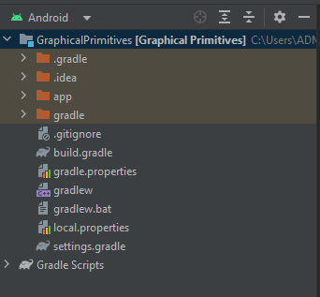

* **Output on Emulator –**

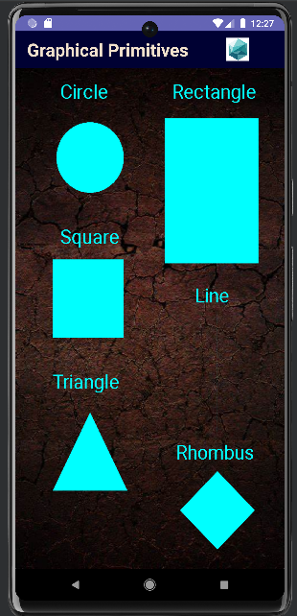

**Conclusion:** Thus we studied the implementation of Easy GUI in Android Studio.